1.20) Write a php program for matrix multiplication.

<?php

 $a1=array(array(1,2,3),array(3,4,5),array(5,10,4));

 $a2=array(array(6,7,8),array(5,9,10),array(7,1,6));

 $a4=array();

 for($i=0;$i<3;$i++)

 {

     for($j=0;$j<3;$j++)

     {

         $a4[$i][$j]=0;

         for($k=0;$k<3;$k++)

         {

             $a4[$i][$j]=$a4[$i][$j]+$a1[$k][$i]+$a2[$j][$k];

         }

     }

 }

 print_r($a4);

 ?>

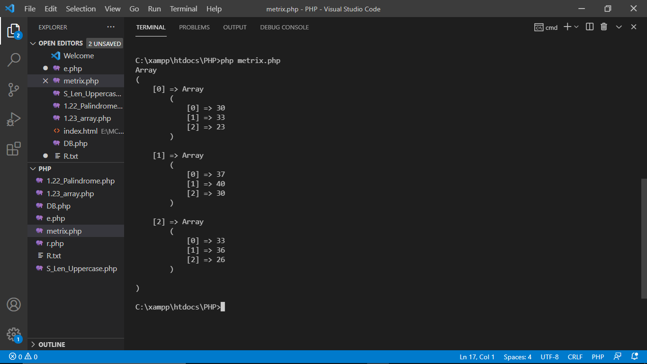

1.21) Write a php program to check the length of given string and display the string in upper case.

<?php

$word="This is the php world";

echo "length of the string is"  , strlen($word),"\n";

echo strtoupper($word);

?>

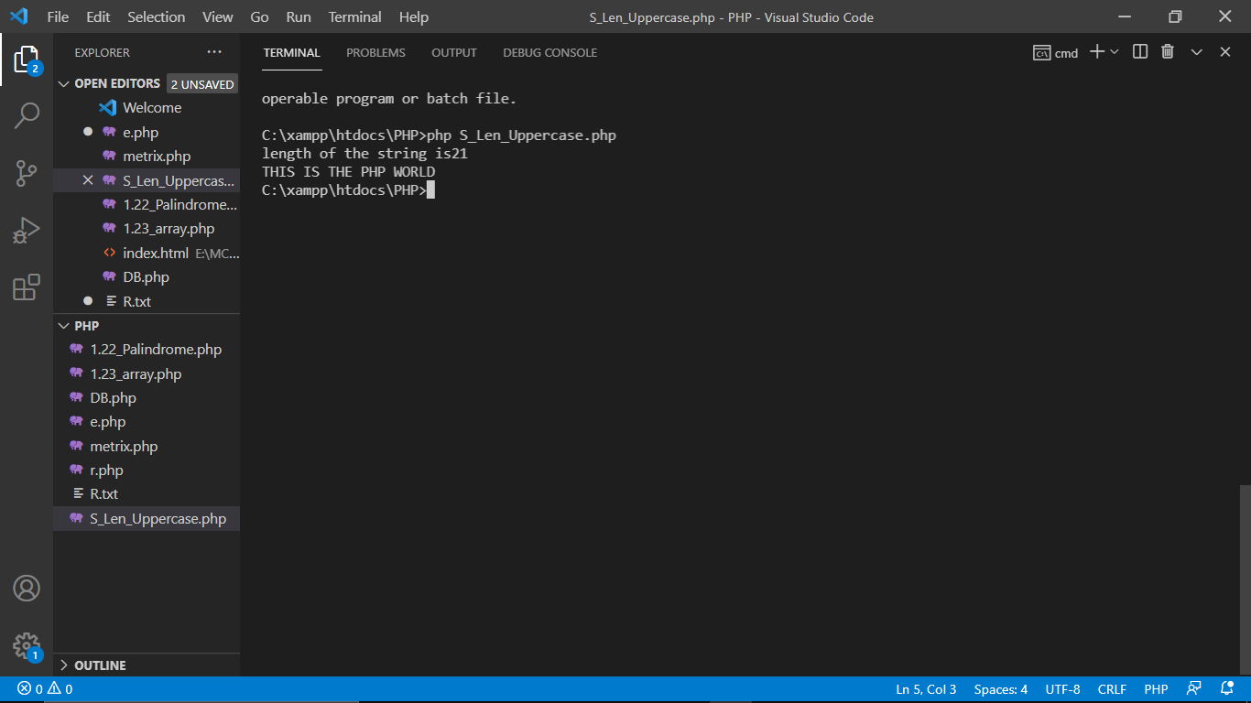

1.22) Write a php program to find if the string is palindrome or not.

<?php

$word="malayalam";

$r=strrev($word);

if($r==$word)

   echo  $r,"  string is palindrome";

else

   echo $r,"  string is not palindrome";

   ?>

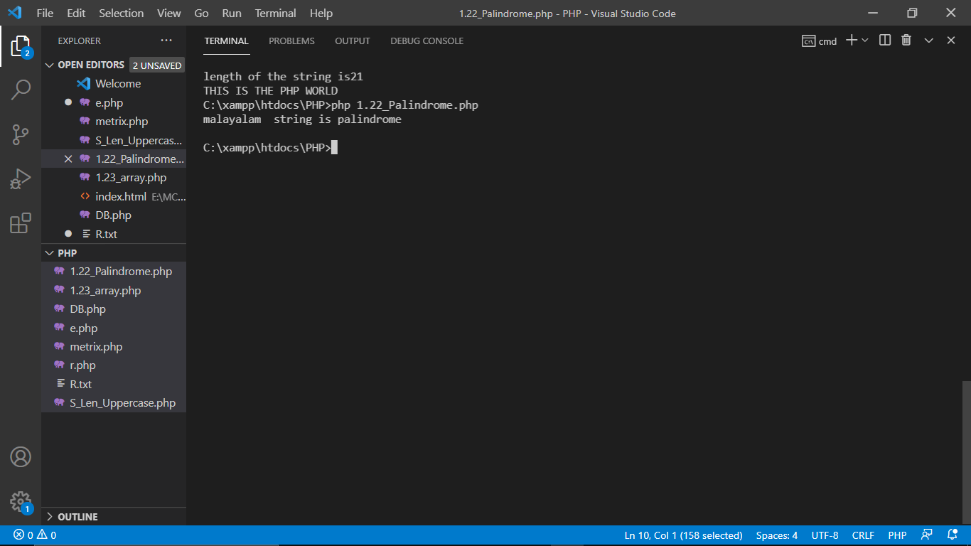

1.23) Write a program to break a sentence and store it in array.

Eg. Sentence: "This is beginning."

array: ([0] => This, [1]=> is, [2] => beginning)

<?php

$sentence="This is beginning.";

$j=explode(" ",$sentence);

print_r($j);

?>

